Operational Concept Description (OCD)

LEAMOS

Team 7

Name | Primary Role
Monty Shah | Project Manager
Pragya Singh | System Architect
Shantanu Sirsamkar | Requirements Engineer
Suchita Doshi | Prototyper
Swapnil Savdekar | Life Cycle Planner
David Wiggins | IIV&V

Version History
Date | Author | Version | Changes made | Rationale
09/27/11 | Suchita Doshi | 1.0 | - Original Template v 1.0 | - Initial draft v1.0
10/07/11 | Suchita Doshi | 1.1 | - Updated Sections 2.1, 2.2,  2.3,2.4 | - Updated after Evaluation  - Corrected mistakes in previous version
10/10/11 | Suchita Doshi | 2.0 | - Completed Section 3 of OCD  - Modified Figure 1 of section 2.4  - Modified Figure 2 of section 2.5 | - Draft of CFCP exit criteria
14/10/11 | Suchita Doshi | 2.1 | - Modified figure of Section 2.4  - Updated Section 3.1.2,1.1, | - Updated After evaluation
10/18/11 | Suchita Doshi | 2.2 | - Updated Section 3.3.4, 3.2.3, 3.2.1, 3.3.2, 3.4 and 3.1.3 | - Fixed bugs
10/23/11 | Suchita Doshi | 2.3 | - Updated Section 2.4 | - Updated 2.4
11/07/11 | Suchita Doshi | 2.4 | - Updated Section 2.4 and Index | - Fixed Bugs
11/21/11 | Suchita Doshi | 3.0 | - Updated Section 1.1 and 3.3 | - Draft of DC Package
12/01/11 | Suchita Doshi | 3.1 | - Updated Section 3.3.1 | - Updated after Evaluation

Table of Contents
Operational Concept Description (OCD) i
Version History ii
Table of Contents iii
Table of Tables iv
Table of Figures v
1. Introduction 1
1.1 Purpose of the OCD 1
1.2 Status of the OCD 1
2. Shared Vision 2
2.1 Success-Critical Stakeholders 2
2.2 System Capability Description 2
2.3 Expected Benefits 3
2.4 Benefits Chain 4
2.5 System Boundary and Environment 5
3. System Transformation 6
3.1 Information on Current System 6
3.2 System Objectives, Constraints and Priorities 8
3.3 Proposed New Operational Concept 12
3.4 Organizational and Operational Implications 13

Table of Tables
Table 1: Success-Critical Stakeholders 2
Table 2: Artifacts 6
Table 3: Level of Service Goals 9
Table 4: Relation to Current System 10

Table of Figures

Figure 1: Benefits Chain Diagram of Leamos 4
Figure 2: System Boundary and Environment Diagram of Leamos 5
Figure 3: Business Workflow Diagram of LEAMOS™ 7
Figure 4: Element Relationship Diagram 13
Figure 5: Business Workflows Diagram for buying Leamos licenses 13

Introduction

Purpose of the OCD
The purpose of the OCD document for the project Leamos is to identify shared vision among the success critical stakeholders. It gives us understanding of the system transformation and overall goals of the system in terms of need and use.

The success critical stakeholders for our project are: Our clients AnaMaria Ruiz and Carlos Gomez, Centro Latino for Literacy organization and the students of the Centro Latino for Literacy.

Status of the OCD
The OCD is version 3.0 of Foundation phase. The document has been updated according to the client’s interactions with us in the Win Win session. This document is now complete and provides all information for the Foundation phase.

Shared Vision

Success-Critical Stakeholders
Table 1: Success-Critical Stakeholders
Stakeholder | Authorized Representatives | Organization | Relation to Benefits Chain
Centro Latino  Admin | AnaMaria Ruiz | Centro Latino for Literacy | - Create, edits, and updates customer and student information.  - Interacts with clients.
Centro Latino Customers | Organizations who purchase Leamos licenses | Various Organizations | - Purchases, renew Leamos licenses for their students.
Leamos Students | Students who take lessons at Centro Latino. | Centro Latino for Literacy | - Take video lessons.
Centro Latino Organization | Owner of Centro Latino Organization | Centro Latino for Literacy | - Maintain organization  - Responsible for paying for current infrastructure.
Developers | Monty Shah, Pragya Singh,Shantanu Srisamkar, Suchita Doshi,  Swapnil Savdekar, David Wiggins | University of Southern California(USC) | - Manages and develops the system for the client  - Verifies the system’s design and functionality  - Moderates discussion between the client and development team

System Capability Description
- Enhance the current system for Centro Latino for Literacy to benefit the students, customers, and the organization.
- Automated account creation for each customer.
- A user friendly interface for students which will have bigger text, continuous flow, minimized clicks, minimal student interaction, less distractions.
- Students will be able to resume the course from where they left off the previous time they logged in.
- A well-documented lesson module to allow easy addition of new online courses for the Centro Latino staff.
- New platform for adding Listos lessons.

Expected Benefits
- The current system is running on two platforms thus the client is spread across two platforms that provide the same overall benefit and maintaining two separate databases for old and new students. The new system will allow clients to maintain only one system that will be running on the Moodle platform. Hence, it will reduce the maintenance cost.
- The site will attract more potential customers, since it will provide videos that will run on all the HTML5 compatible browsers and all the modern devices like smart phones, tablets etc.
- More Accessible videos will increase the number of students which will result in more donors.
- The site will also provide instant access to the courses because of the new sales Website. Will also provide a new electronic database for the customers.
- Ease of adding lessons, with the help of clear documentation, for Centro Latino staff so that they don’t need to pay developers for that work.
- Easily maintainable system.

Benefits Chain

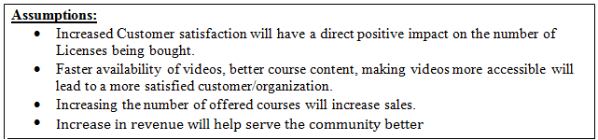

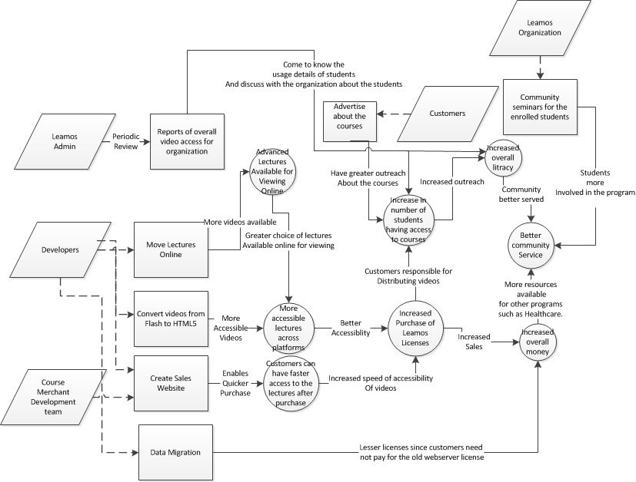

Figure 1: Benefits Chain Diagram of Leamos

System Boundary and Environment

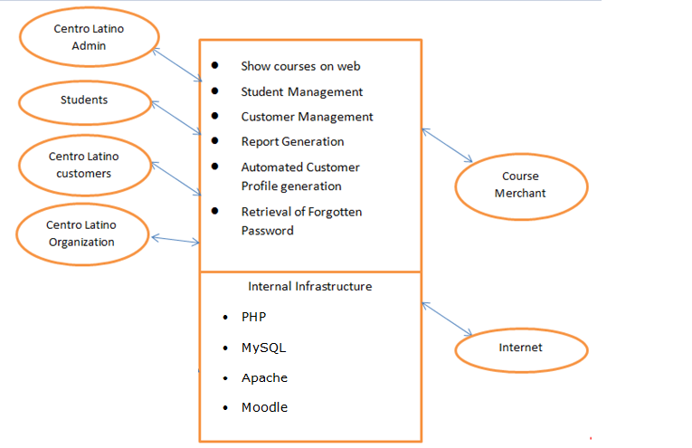

Figure 2: System Boundary and Environment Diagram of Leamos

System Transformation

Information on Current System

Infrastructure
Hardware:
Desktops with Windows XP

Software tools:

- Microsoft SQL Server
- MYSQL
- Moodle

Operating Systems: Windows XP
Web Browsers: Internet Explorer 8, Mozilla Firefox, Google Chrome
Network: No Intranet only access to Internet
Web Server: Apache Web Server, IIS.

Artifacts
Table 2: Artifacts
Artifact | Description
Student Profile | Provides information about the Student. Eg. Student name, username, password, courses completed, etc.
Courses | Courses comprised of the flash files, context information and other related information.
Flash files | The flash files which are in AS 2.0 SWF 8.0 format need to be converted to HTML5 to make it compatible with modern browsers. In order to get some information regarding conversion, we requested for one of the flash files.
Customer Profile | Provides details about the customer/organization. Eg: Customer name, address, phone number, email address, number of licenses owned etc.
Student Courses Report | Contains both the student details and the courses completed (progress) with their marks for each lesson.

Current Business Workflow

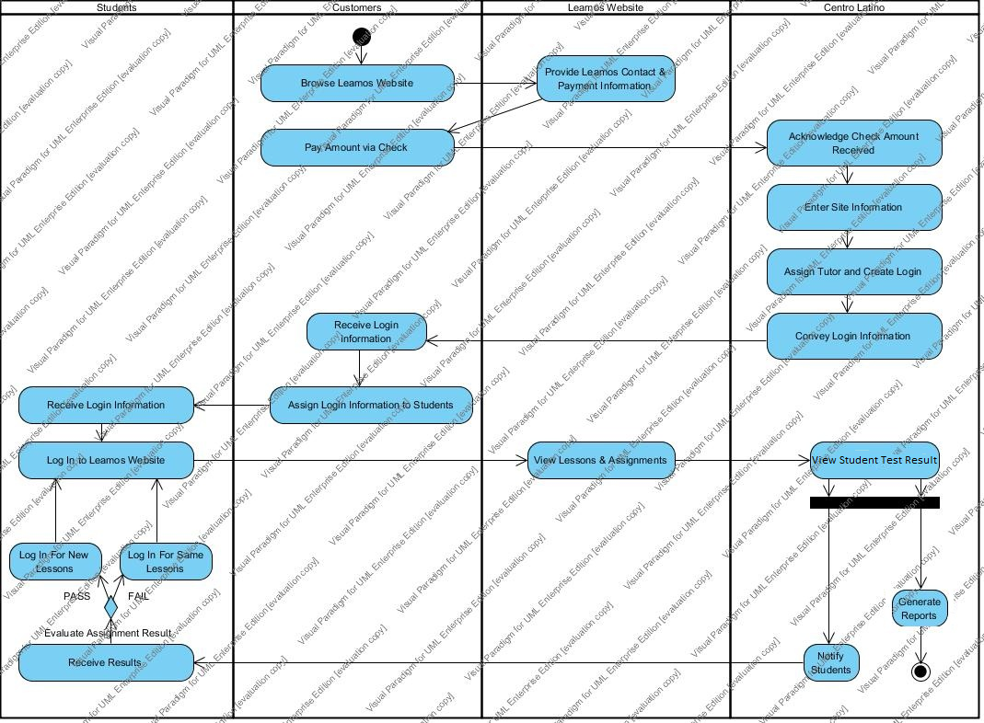

Figure 3: Business Workflow Diagram of LEAMOS™

System Objectives, Constraints and Priorities

Capability Goals

Capability Goals | Priority Level
OC-1 Simple username and password for the users: There should be simple username and password for the students so that they can remember the credentials easily. | Must Have
OC-2 Flash to HTML 5 conversion: The old lessons, currently in Flash format should be converted in HTML 5 format which will allow the users to watch the lessons on any HTML 5 supported browser | Must Have
OC-3 Data Migration: The old database, currently in MS SQL, needs to be migrated in the new Database in MySQL which will help the system admins to maintain only a single database instead of two. | Must Have
OC-4 Integrate the current system with third party merchant system: The current system should allow the users to buy the course licenses online. This will help the users to get faster access to the courses. | Must Have
OC-5 Availability of username and password immediately after buying courses: The customers buying the licenses should be provided with an immediate automated username and password. | Must Have
OC-6 Report generation: The admin should be able to generate reports to track the progress of the students and maintain various other records. | Must Have
OC-7 Documentation/Video Tutorials: Easy to understand documentation and video tutorials should be provided to the admin which will help them in maintaining the site easily (how to add/ remove courses etc.) without the requirement to hire another set of developers to do the same task. | Must Have
OC-8 Forgot Password functionality: The system should provide the users a “forgot password” option if they forget their passwords, which will provide them their respective passwords on confirming their identity instead of contacting the admin every time to provide them with their passwords. | Could Have
OC-9 Videos in HTML 5 format: The system should be able to allow the students to watch lectures online on the Leamos website on HTML 5 supported devices and browsers. | Must Have
OC-10 User management to other Organizations: The system should be able to provide the organizations who buy licenses as an Independent site, to be able to manage their students independently. | Could Have
OC-11 Sales Website: Provide the users a website which will enable them to enter all their credentials (eg. Name, address, no. of courses to buy etc.) to buy the course license online through a third party merchant securely. | Must Have

Level of Service Goals
Table 3: Level of Service Goals
Level of Service Goals | Priority Level
LOS-1: Availability: The system should be up and running at all possible times except for maintenance time or system shut down | Must have
LOS-2 Security: The system should be able to provide secure transfer of funds when a customer buys license(s) and pays online. This is done by Course Merchant. | Must have
LOS-2 Ease of use: The system should be easy to use so that it is easier for the students to adapt the system | Must have

Organizational Goals

OG-: Increased Sales: Increase the sales by providing users faster access to the course Licenses and more access to videos and hence spreading more Spanish literacy.
OG-2: Cost savings: Maintaining two databases is a tedious task and also it costs a lot to host two databases. Hence, migration of data will reduce the cost.
OG-3: Students Satisfaction: Satisfy the students by providing access to more videos and “easy to use interface” along with the provision of watching the in class lectures online. This will attract more students.
OG-4: Attract more donors: By providing more access to videos and also providing the Leamos lectures online will attract more students, which will result in more donors.
OG-5: Ease of Maintenance: With the migration of old database to the new database, the maintenance will be less hectic for the admins.

Constraints

CO-1 Moodle Platform: The system is to be built on Moodle platform.

CO-2 PHP: PHP will be used to design the website and do the server side scripting.

CO-3 MySQL: All the data from the old data base has to be migrated to MySQL database.

CO-4 HTML5: The videos will run on HTML5 environments.

CO-6 Schedule: The system needs to be deployed in the given time frame.

Relation to Current System
Table 4: Relation to Current System
Capabilities | Current System | New System
Roles and Responsibilities | - The Centro Latino for Literacy admins needs to maintain 2 databases | - The data from the old database will be migrated to the new database and hence only one database needs to be maintained
User Interactions | - Pay the courses manually via checks and after the payment is done, admin will have to manually create the account.  - Call the admin every time a user forgets his/her password  - Users watch lectures in Flash videos | - Automate the creation of user account after the payment is done through a 3rd party payment gateway.  - A Forgot Password link which will provide the users their passwords on answering some questions.  - Users will get to watch the lectures in HTML5 supported browsers and devices.
Infrastructure | - There are two systems running in the client place, new system on Moodle, MySQL and PHP and old system is running on MS SQL and ASP | - The new system will run only on Moodle with a third party merchant to enable online payments.
Stakeholder Essentials and Amenities | - Manual account creation by the admins.  - Collect information from 2 databases and manually generate the report | - Automated creation of user accounts  - Generate the reports automatically since the overhead from fetching the data from 2 databases is now eliminated, so now the reports can be directly generated from a single database.
Future Capabilities |  | - Automating the addition of courses.

Proposed New Operational Concept

Element Relationship Diagram

Report Generator
View customer/organization and/or student reports

A
U
THENTICATION

Role Authorizer (roles include student, client, admin)

M
O
O
D
L
E
Create/
edit student profile

Database
Student Record,
Video files,
Customer Record
Admin record
Query

Role Authorizer

Client

Users
View
courses

Login id

Password

Student
Create/
edit customer profile

Admin
Query

Automatic Profile Generation
Customer Records

Customer Records

Send Success notification

Payment Information
Sales
Website

Customers
Choose type, number of Licenses

Course
Merchant

Figure 4: Element Relationship Diagram

Business Workflows
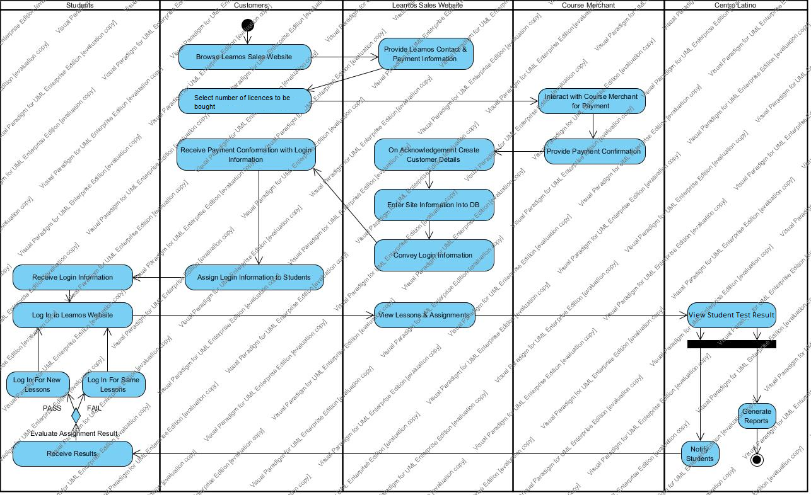
Figure 5: Business Workflows Diagram for buying Leamos licenses

Organizational and Operational Implications

Organizational Transformations
- Elimination of maintaining two databases and saving the cost of hosting two servers.
- Eliminating the overhead of creating the customer/student’s profile manually by automating the system.
- Allow the users to retrieve their password with the “Forgot password” facility, which solves the problem of every time calling the admin and asking the password.

Operational Transformations

- Provision of simple login page that will make the life of students easy.
- Conversion of the flash files to HTML5, allowing the users to watch the lectures from modern browsers and other devices which support HTML5 environment.
- The feature of resuming the courses from where the students previously left off after logging in to the system.

